**Experiment 4: Apply CSS to Style an HTML Page**

**Aim:**

To apply CSS to style an HTML page with different properties like color, font-size, margin, padding, and borders.

**Learning Objectives:**

* Learn the basics of CSS.
* Understand how to apply CSS styles to HTML elements.

**Theory:**

Cascading Style Sheets, fondly referred to as CSS, is a simple design language intended to simplify the process of making web pages presentable. CSS handles the look and feel part of a web page. Using CSS, you can control the color of the text, the style of fonts, the spacing between paragraphs, how columns are sized and laid out, what background images or colors are used, as well as a variety of other effects. CSS is easy to learn and understand but it provides a powerful control over the presentation of an HTML document. Most commonly, CSS is combined with the markup languages HTML or XHTML.

A CSS comprises style rules that are interpreted by the browser and then applied to the corresponding elements in your document. A style rule is made of three parts:

* Selector: A selector is an HTML tag at which a style will be applied. This could be any tag like <h1> or <table> etc.
* Property: A property is a type of attribute of an HTML tag. Put simply, all the HTML attributes are converted into CSS properties. They could be color, border, etc.
* Value: Values are assigned to properties. For example, color property can have the value either red or #F1F1F1 etc.

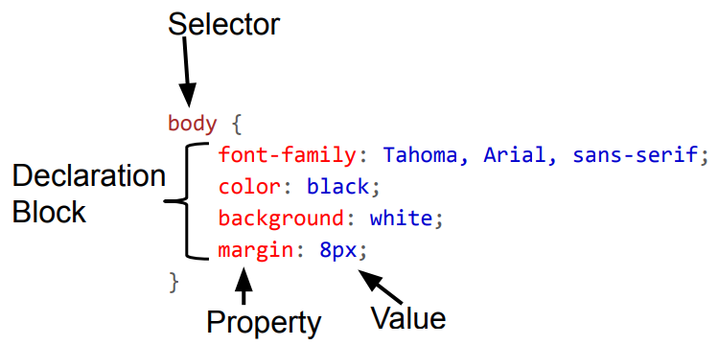

Multiple CSS declarations are separated with semicolons, and declaration blocks are surrounded by curly braces.

# How To Add CSS

There are three ways of inserting a style sheet:

* External CSS
* Internal CSS
* Inline CSS

## External CSS

With an external style sheet, you can change the look of an entire website by changing just one file!

Each HTML page must include a reference to the external style sheet file inside the <link> element, inside the head section

* HTML file
* CSS file

## Internal CSS

An internal style sheet may be used if one single HTML page has a unique style.

The internal style is defined inside the <style> element, inside the head section.

## Inline CSS

## Inline CSS is a method of applying CSS (Cascading Style Sheets) directly to HTML elements using the style attribute within the opening tag of an element.

## This approach allows you to define specific styles for individual elements on the fly, without needing to reference an external stylesheet or embedding styles in the <head> section of the HTML document.

**CSS Colors:** CSS color properties allow you to set the color of text, backgrounds, borders, and other elements in your web pages.

## CSS Background Color: The background-color property in CSS sets the background color of an element. It can be applied to various HTML elements such as body, div, p, and more. You can specify colors using named colors, hexadecimal values, RGB, RGBA, HSL, and HSLA.

**CSS3 fonts:** CSS allows you to style text by applying various font properties. These properties control the font family, size, weight, style, and more.

**CSS Tables:** CSS allows you to style HTML tables to improve their appearance and usability.

**Code****:**

index.html:

<!DOCTYPE html>

<html lang="en">

<head>

    <meta charset="UTF-8">

    <meta name="viewport" content="width=device-width, initial-scale=1.0">

    <title>About Me</title>

    <link rel="stylesheet" href="styles.css">

</head>

<body>

<div class="about">

    <h1>About Me</h1>

    <p>Hi, my name is <span>Aditya Kirti</span>. I am an <span>IT Engineering

        Student</span> with a passion for <span>Programming</span>. In my free time, I enjoy various

        activities and hobbies like <span>listening to music, reading books, exploring new things,

        and programming</span>.</p>

</div>

<div class="fav">

    <h1>My Favorite Movie</h1>

    <dl>

        <dt>Title</dt>

        <dd>Deadpool & Wolverine</dd>

        <dt>Director</dt>

        <dd>Shawn Levy</dd>

        <dt>Year</dt>

        <dd>2024</dd>

        <dt>Description</dt>

        <dd>Deadpool's peaceful existence comes crashing down when the Time Variance Authority recruits him to help

            safeguard the multiverse. He soon unites with his would-be pal, Wolverine, to complete the mission and

            save his world from an existential threat.</dd>

    </dl>

</div>

</body>

</html>

style.css:

body {

    font-family: Roboto, sans-serif;

    margin: 20px;

    background-color: #d50224;

}

.about, .fav {

    display: flex;

    flex-direction: column;

    justify-content: center;

    align-items: center;

    background-color: #fee218;

    border: thin solid black;

    padding: 20px;

    margin: 10px 0;

}

span {

    font-weight: bolder;

    font-family: Consolas, monospace;

    color: #d50224;

}

h1 {

    color: #000;

    font-family: Roboto, sans-serif;

    text-align: center;

    margin-bottom: 20px;

}

p {

    font-size: 16px;

    line-height: 1.5;

    margin: 0 0 20px 0;

    text-align: justify;

}

dl {

    border: thin solid black;

    padding: 20px;

    background-color: #fff;

    max-width: 600px;

    margin: 0 0;

}

dt {

    font-weight: bold;

    margin-top: 10px;

}

dd {

    margin-left: 20px;

    margin-bottom: 10px;

}

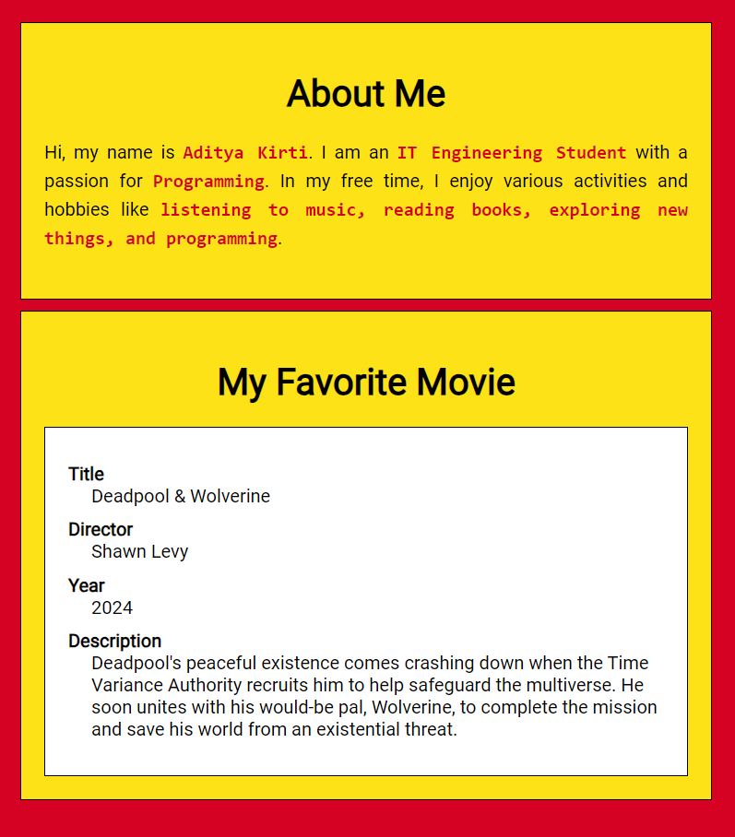**Output:**